Date: 4th July 2023

Ram Lal Anand College
University Of Delhi
Semester II Practical Examination July 2023
Date Sheet
Department of Environmental Studies

Date &  Day | Time of Commencement | Practical | Unique paper code | Room No. | Course
11 July 23  (Tuesday) | 9:00 AM to 12:00 Noon | AEC- Environmental Science Practical | 2181001001 | 14 | B.Com (Programme)
11 July 23  (Tuesday) | 9:00 AM to 12:00 Noon | AEC- Environmental Science Practical | 2181001001 | 12 | B.A. English (Hons)
11 July 23  (Tuesday) | 2:00 PM to  5:00 PM | AEC- Environmental Science Practical | 2181001001 | 12 | B.Com (Hons)
12 July 23  (Wednesday) | 9:00 AM to 12:00 Noon | AEC- Environmental Science Practical | 2181001001 | 12 | B.A. (Programme)
12 July 23  (Wednesday) | 9:00 AM to 12:00 Noon | AEC- Environmental Science Practical | 2181001001 | 14 | B.A. History (Hons)
12 July 23  (Wednesday) | 2:00 PM to  5:00 PM | AEC- Environmental Science Practical | 2181001001 | 14 | B.A. Hindi (Hons)
14 July 23  (Friday) | 9:00 AM to 12:00 Noon | AEC- Environmental Science Practical | 2181001001 | 12 | B.A. Political Science (Hons)

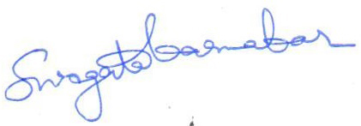
Dr. Swagata Karmakar
Assistant Professor
Department of Environmental Studies
Ram Lal Anand College

