National Service Scheme
Ram Lal Anand College
(University of Delhi)
20.11.2020

NOTICE

This is to notify that NSS unit of our college is recruiting volunteers from first and second year students of various courses. Please apply through the following link latest by 26th November, 2020.

https://forms.gle/PLSMWTmXrKwWnJi77

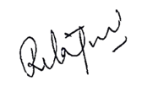
Dr Rita Jain
NSS- Program Officer

